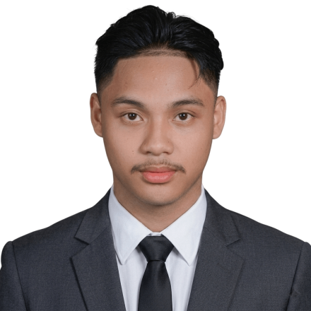
LESTER DANN G. LOPEZ
Full-Stack Developer | AI & Automation | Data Science | Robotics
Lesterdannlopez7@gmail.com
09943114963
dannlopez.vercel.app
linkedin.com/in/lester-dann-lopez-26874b190

OBJECTIVE
Computer Science student and full-stack developer who builds intelligent SaaS apps and automates business workflows using n8n and AI agents. I help organizations scale by replacing manual tasks with smart automation, leveraging my data science background for predictive analytics and data-driven insights.
TECHNICAL SKILLS
- AI & Automation: n8n workflow automation, AI-assisted development (Claude/Vibe Coding), building & deploying AI agents
- Data Science & ML: pandas, scikit-learn, NumPy, Matplotlib — prediction models, classification, regression, analytics
- Full-Stack Web: Next.js 15, React, TypeScript, Tailwind CSS, Shadcn/UI, Supabase (Auth & Database), PostgreSQL, REST APIs, React Native
- Languages & Tools: Python, TypeScript/JavaScript, C++, Git/GitHub, Vercel
- Robotics: Fusion 360, Creality Print, Arduino
See more skill, languages, frameworks and tools I have used at https://dannlopez.vercel.app/#skills
PROJECTS & EXPERIENCE
- ChrisAutoshine (Australia) — Freelance business website for an Australian automotive detailing company, delivered remotely.
- NextViz — Self-built n8n alternative that runs inside Next.js — no VPS required. Makes workflow automation native to SaaS apps.
- AttyJuan — AI Legal Scheduling — AI-powered scheduling & case management system for Philippine legal professionals.
- NutriFriendly AI — AI nutrition assistant with personalized meal recommendations via ML and NLP.
- FlashLearner AI — Adaptive flashcard platform with spaced repetition and AI-generated study content.
- AdventFlow — Seventh-day Adventist Church management web app for scheduling, announcements, and congregation coordination.
- DannFlow — Production-ready Next.js 15 starter boilerplate — personal base template for rapid SaaS development.
- LGU Solano — Marriage License System — Government system that digitizes marriage license applications for the Local Government Unit of Solano.
See more projects and live demos at https://dannlopez.vercel.app/#projects
EDUCATION
2026 (Present) - Bachelor of Science in Computer Science (Robotics) — 3rd Year Nueva Vizcaya State University (NVSU) — Bayombong, Nueva Vizcaya
LICENSES & CERTIFICATIONS
- Python Essentials 1 Cisco · May 2026
- Crash Course on Python Google · Dec 2024
- Introduction to Git and GitHub Google · Dec 2024
- Learn C++ Programming — Beginner to Advance Udemy · Aug 2024
- Start the UX Design Process: Empathize, Define, and Ideate Google · May 2024
- Foundations of User Experience (UX) Design Google · May 2024
- GCI World 2026 Tokyo University - Data Science and Machine Learning
View all verified credentials at https://dannlopez.vercel.app/#credentials

